Integration: You can integrate with other tools

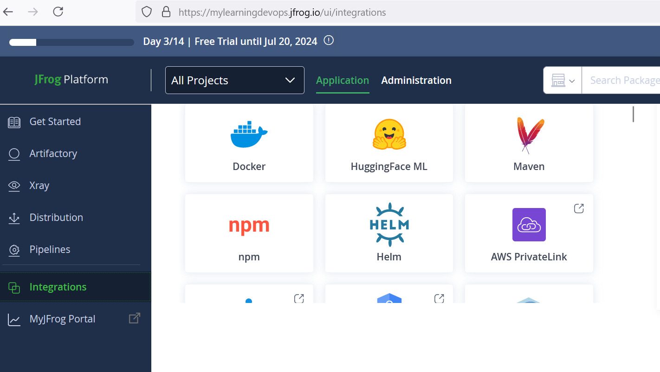

Generating token

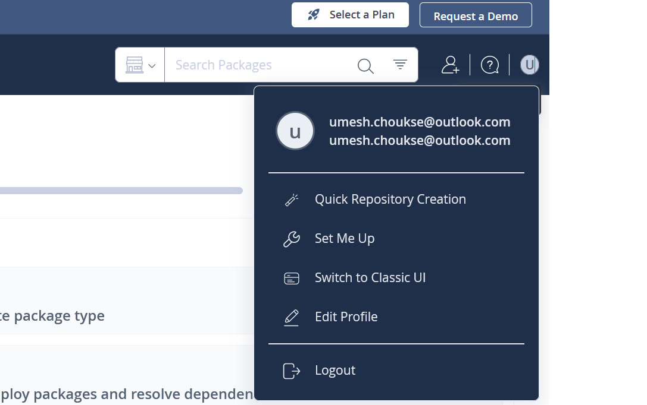

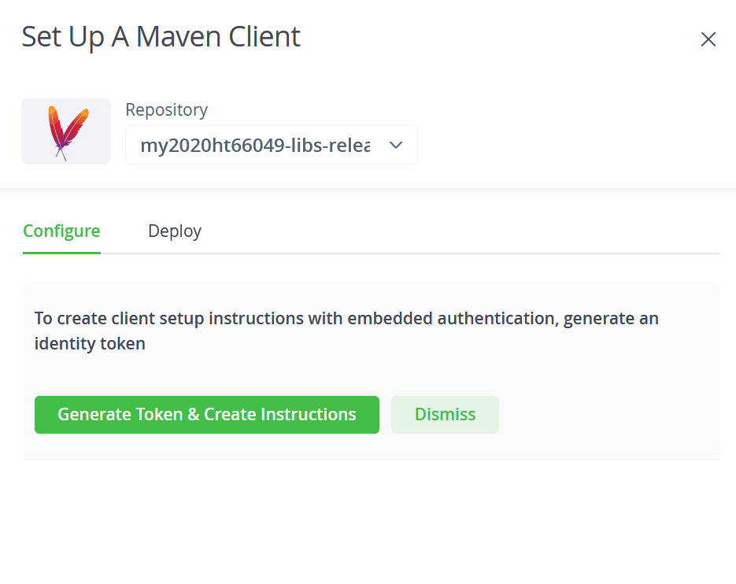

JFROG installation

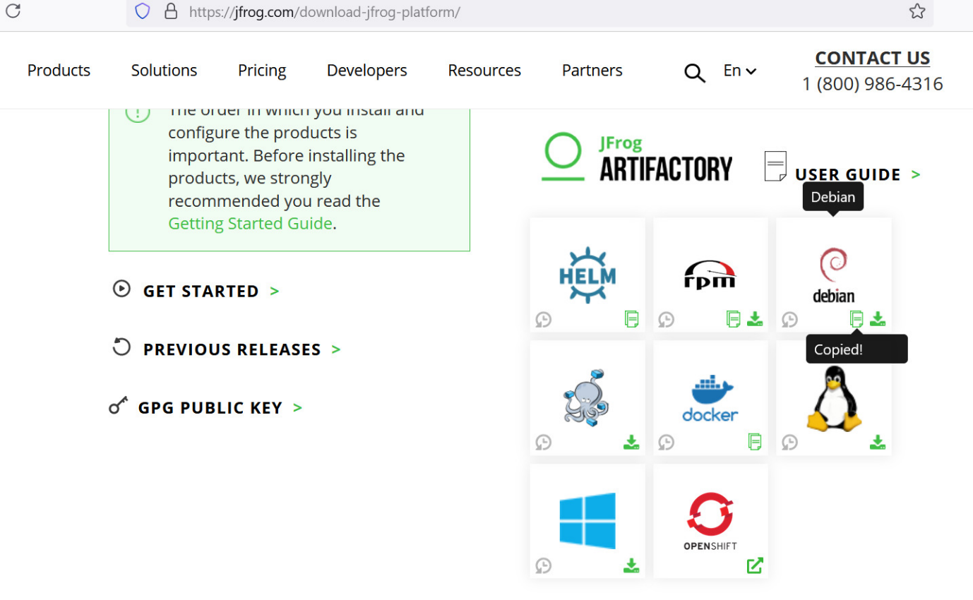

Service connection: <https://github.com/jfrog/jfrog-azure-devops-extension/blob/v2/README.md>